Steps to create the google VM and cloud account and installing the google cloud SDK
- Authenticated my gmail account (j2ee.nj@gmail.com) for using the google cloud. Had to give my credit card details.
- Downloaded the google cloud api software.
  - The software does not install properly if you are inside the office network. I switched to my personal mobile network and got it installed.
  - Attached the gmail account to this.
  - Instructions are in: https://cloud.google.com/sdk/docs/quickstart-windows
- Created a VM by going into the Google Compute Engine (4 GB RAM). This is very similar to the AWS VM creation process but fewer questions. Also, the IAM is tightly integrated with the gmail account credentials.
- Tried doing a browser based SSH. Again this will not work in our office. I had to use my personal mobile network.
- Once all this is done, I was able to run normal Ubuntu commands:
  - sudo apt-get update
  - sudo apt-get install openjdk-8-jdk – Installed Java 8

Screenshot 1: Creating the VM instance

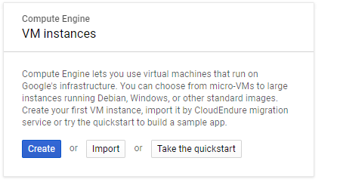

Screenshot 2: Create instance
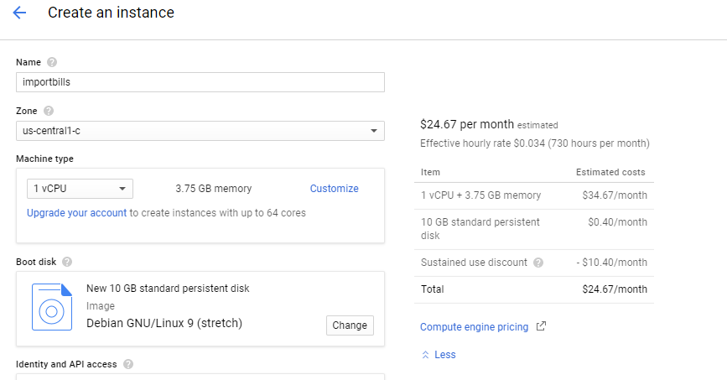

Screenshot 3: Logging into the instance using the browser based SSH
Here, this works only on private networks

